Shin Thant Aung

14191080

CP-1407

Introductory Machine Learning and Data Science

Assignment – 1

Due date: 21.5.2023 (12:00am)

First view of wine_train.arff

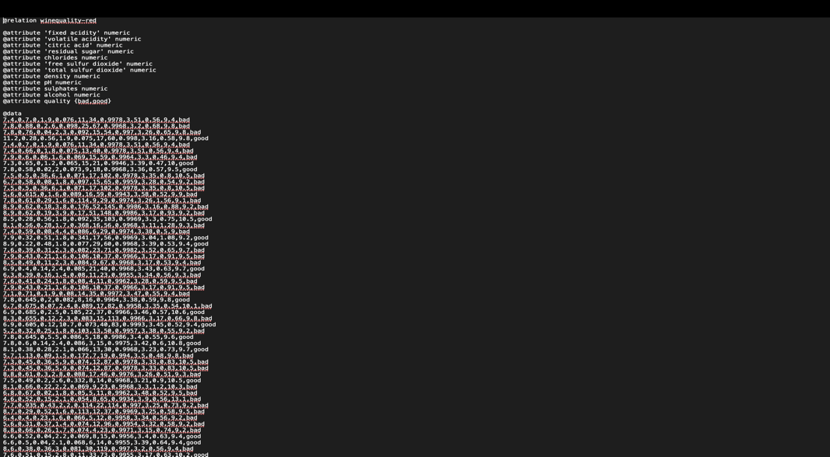

Opening the ArffViewer

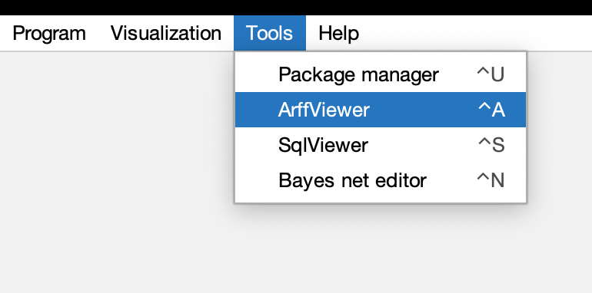

Opening the wine_train.arff in ArffViewer

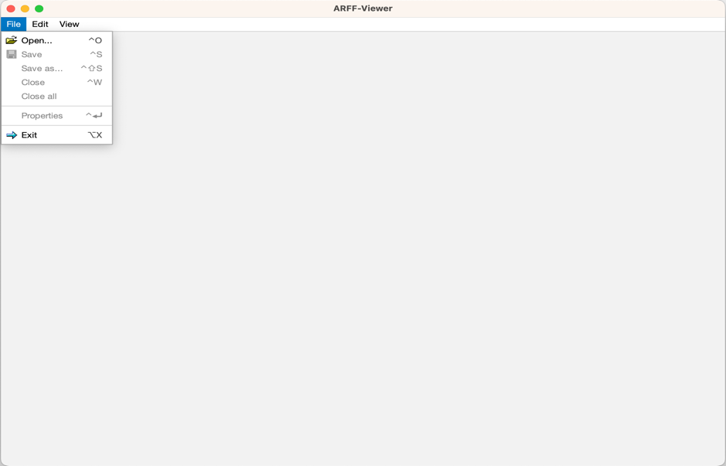

Opening the wine_train.arff

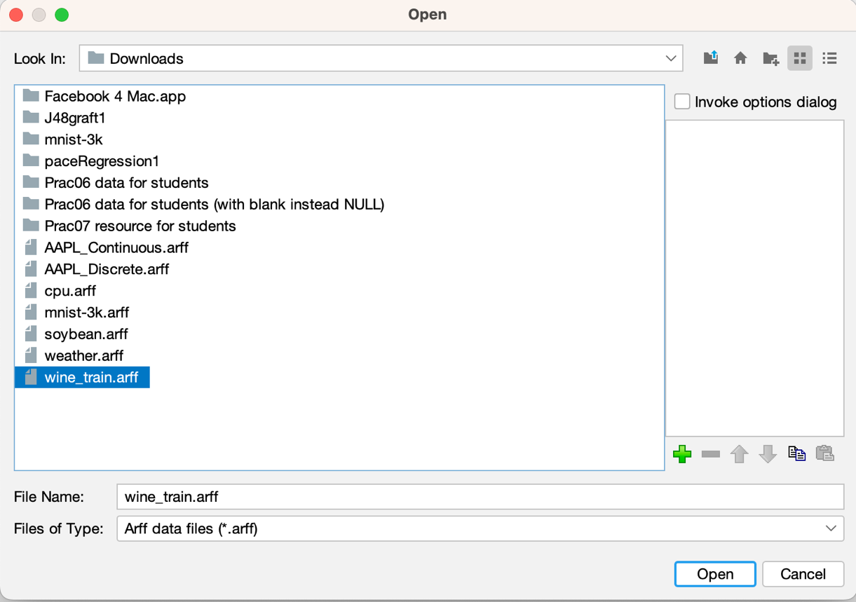

Displaying wine_train.arff in ArffViewer

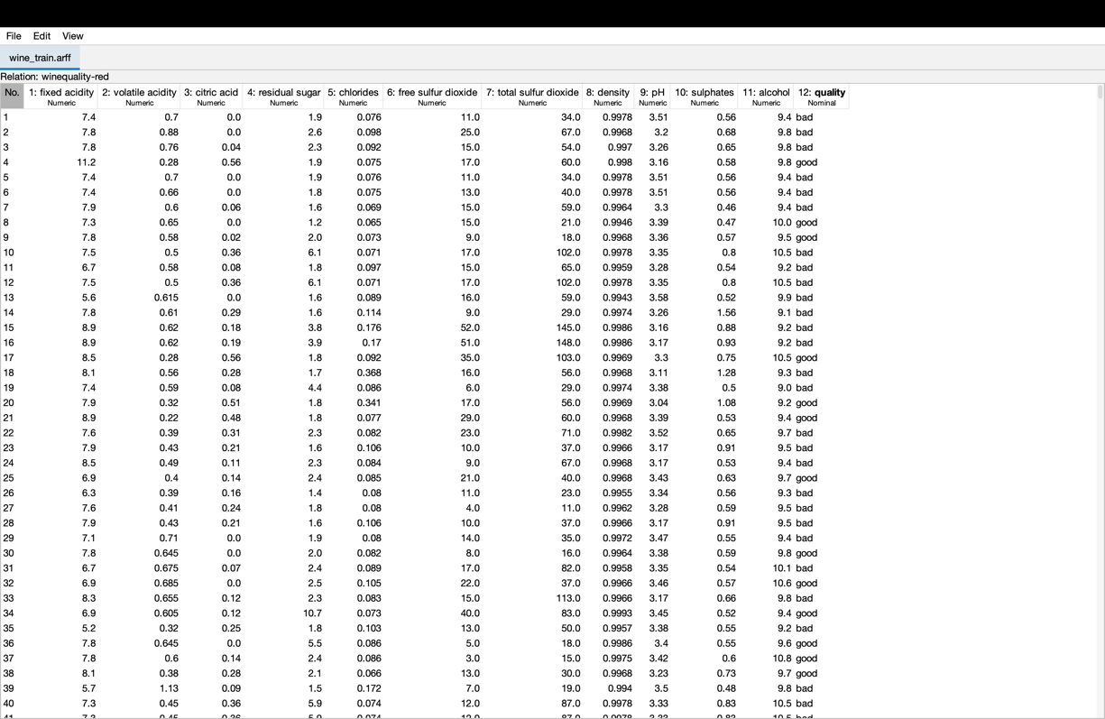

Displaying a.arff in ArffViewer

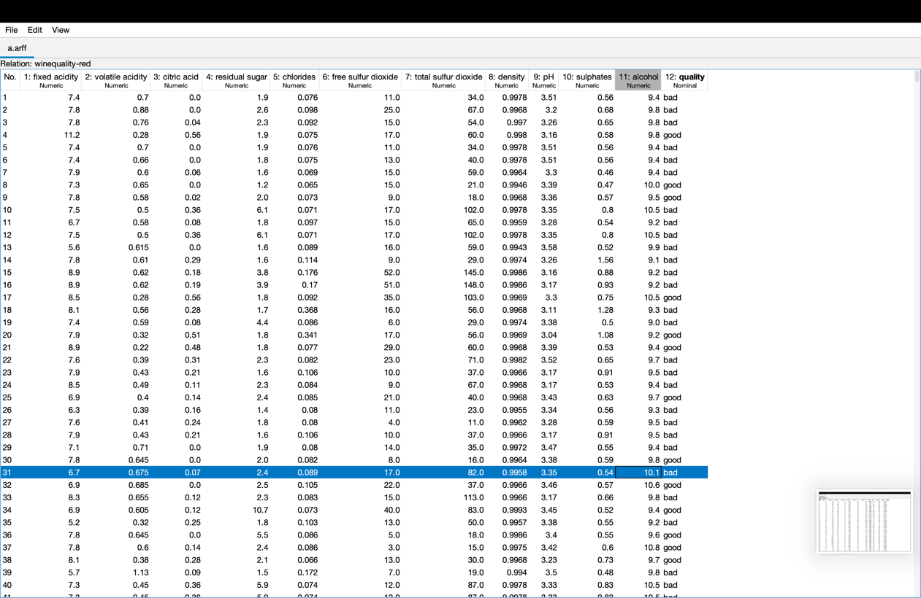

Opening wine_train.arff in Explorer

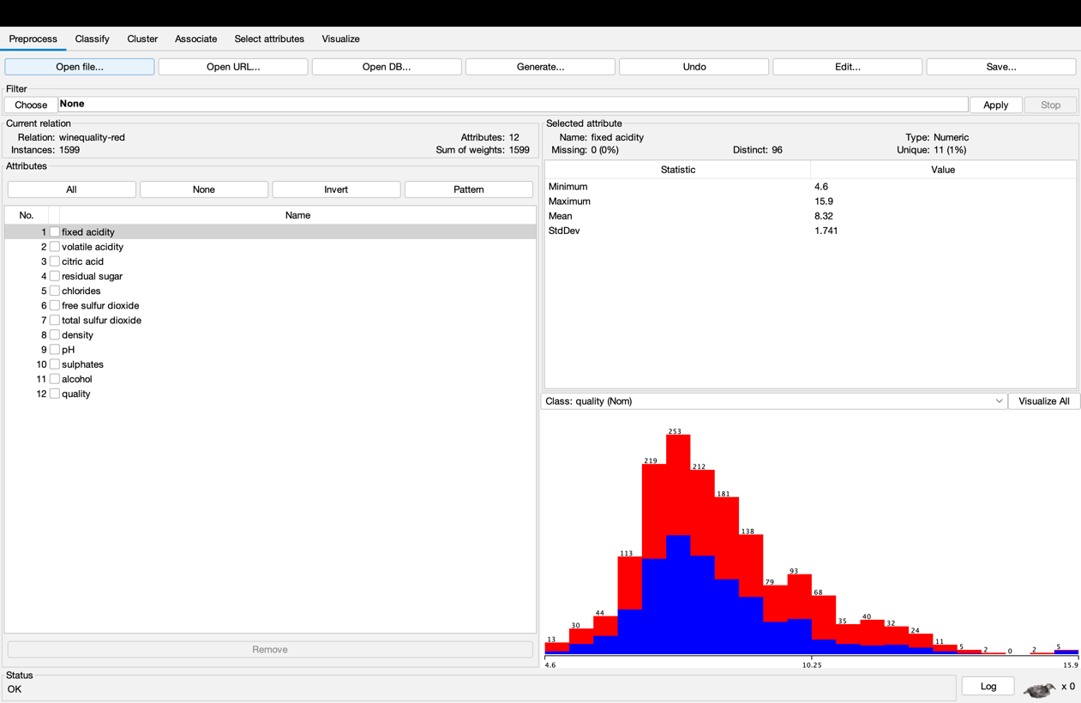

View all the histograms of wine_train.arff

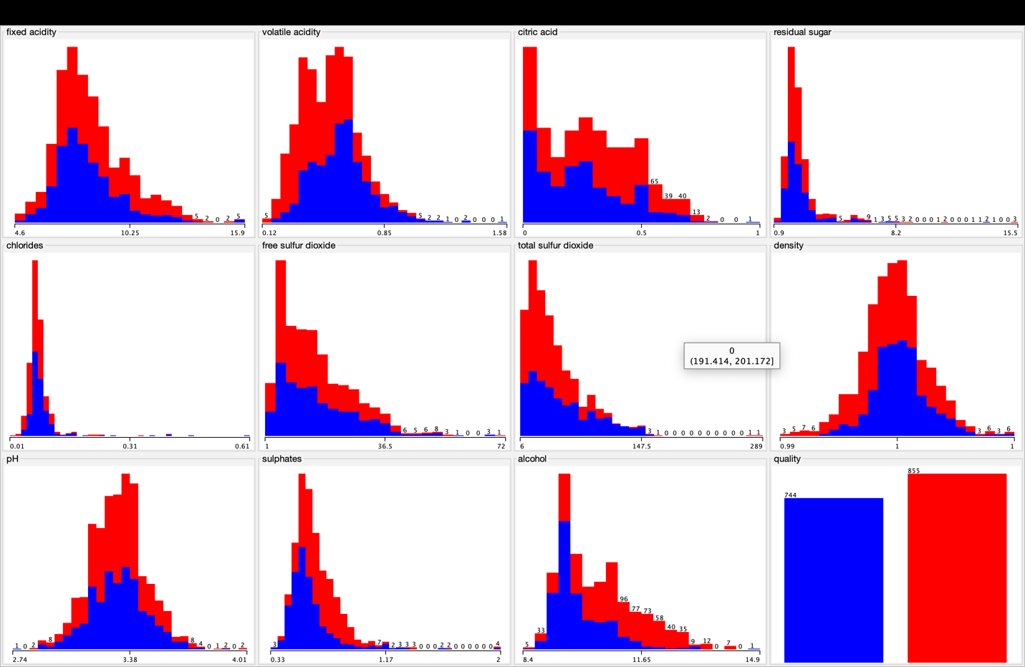

Question #1: [10 marks]

Which attributes in the training set do not appear to have a "hump" distribution? Which attributes appear to have outliers? (Do not worry too much about being precise here. The point is for you to inspect the data and interpret what you see.)

Based on the histogram, which attribute appears to be the most useful for classifying wine, and why?

Citric acid and Quality are the only attributes in the training set that does not appear to have a “hump” distribution.

Quality attribute appear to have an outlier because unlike other attributes, this attribute can be considered as binary data type as it can only considered as “good” and “bad”.

Residual Sugar and Chlorides can also be accepted as outliers because of its rapid ups and downs. Such attributes have tightly associated in a small data range unlike the rest of the dataset.

Volatile acidity appears to be the most useful for classifying wine when trying to identify using only histogram. This is due to the number of good and bad distribution was seem to be average as the increasing of histogram occurs but as it decreases, the number of bad increases and gets distinct.

Model of the ZeroR Algorithm

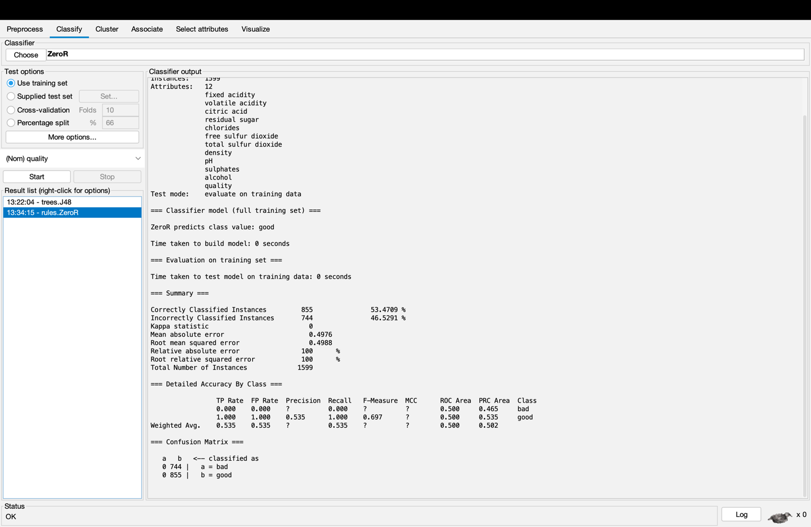

**Question #2: [10 marks]**

What is the *accuracy* - the percentage of correctly classified instances - achieved by *ZeroR* when you run it on the training set? Explain this number (what this number means …). How is the accuracy of *ZeroR* a helpful baseline for interpreting the performance of other classifiers?

The accuracy is 53.4709 percentage when trying to run with the algorithm on the training set. The accuracy is quite low. This can be due to the error occurring when calculating the precision rate of the class, bad.

The accuracy is the overall correctness of the predictions made by the model.

The number in the accuracy represent that in the model, the model predicts several outcomes based on the data input and only 53.4709 percentage of the outcomes are in the right direction. Therefore, if the model predicts the outcomes of 100 cases, 53 of then will be correct when the rest may be mistaken.

The accuracy of ZeroR is really low when comparing with the performance of other classifiers. The accuracy of ZeroR shows us how the outcomes of the model can be interfered by the accuracy such as having an error or having very low TP rate, FP rate and etc.

Based on the accuracy of the ZeroR, we can know that if the accuracy of the model is low, the error rate is high and the performance is poor. If the accuracy of the model is high, the error rate is low and the performance is high. Therefore, we can determine that the performance of the model is good or is the result is trustable by looking at the accuracy of the model.

Model of J48 Algorithm running on training set

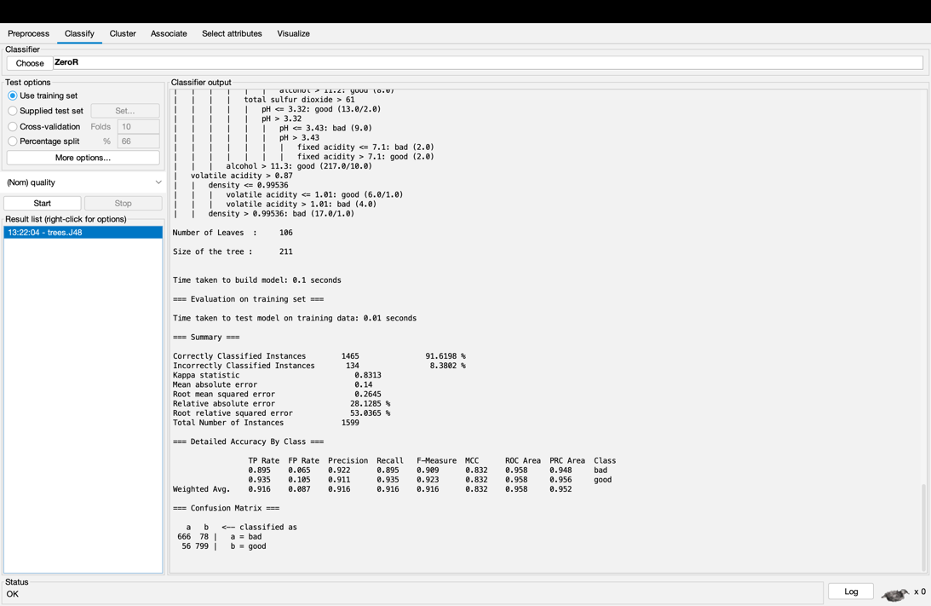

Decision Tree of J48 Algorithm running on training set

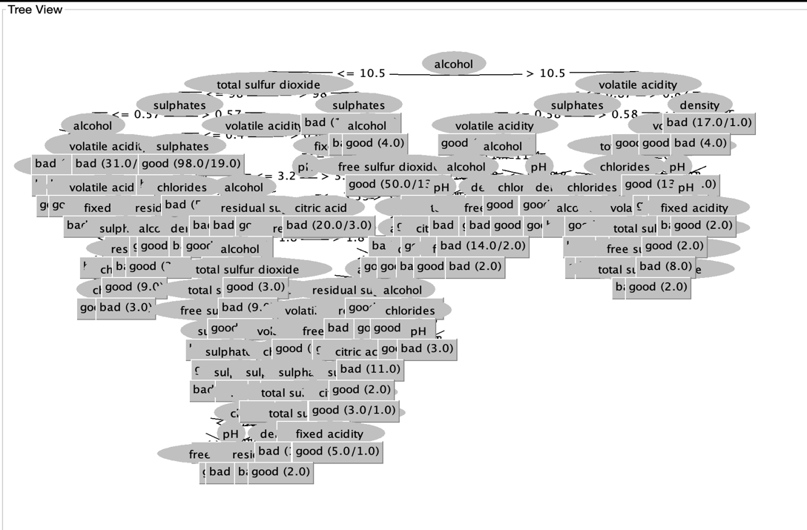

**Question #3: [10 marks]**

Using a decision tree Weka learned over the training set, what is the most informative single feature for this task, and what is its influence on wine quality? Does this match your answer from Question #1?

The most influence feature based on J48 algorithm is alcohol. As we can see in the tree, alcohol is at the start of the tree. I think it is due the average of distribution of how quality take place in the histogram of alcohol.

When the alcohol percentage is over 10.5, there are more good quality of the wine than bad ones but when the alcohol percentage is same or below 10.5, there are less good quality wine than bad ones. If the alcohol percent is more than 10.5, there will be some classification to come out with the result of good = 2 and the rest bad. But if the alcohol percentage is below or equal to 10.5, there will be a net of classification with many results coming out such as good = 2.0, bad = 3.0 and etc. This is how the alcohol influence the wine quality.

This doesn’t match my answer from the Question 1 but I consider that I was close as the histogram based on the volatile acidity has a similar distribution of the quality of the wine to that of alcohol. I also consider that about the distribution of quality but not as an algorithm would consider.

Model of J48 Algorithm running with 10 folds of Cross-validation

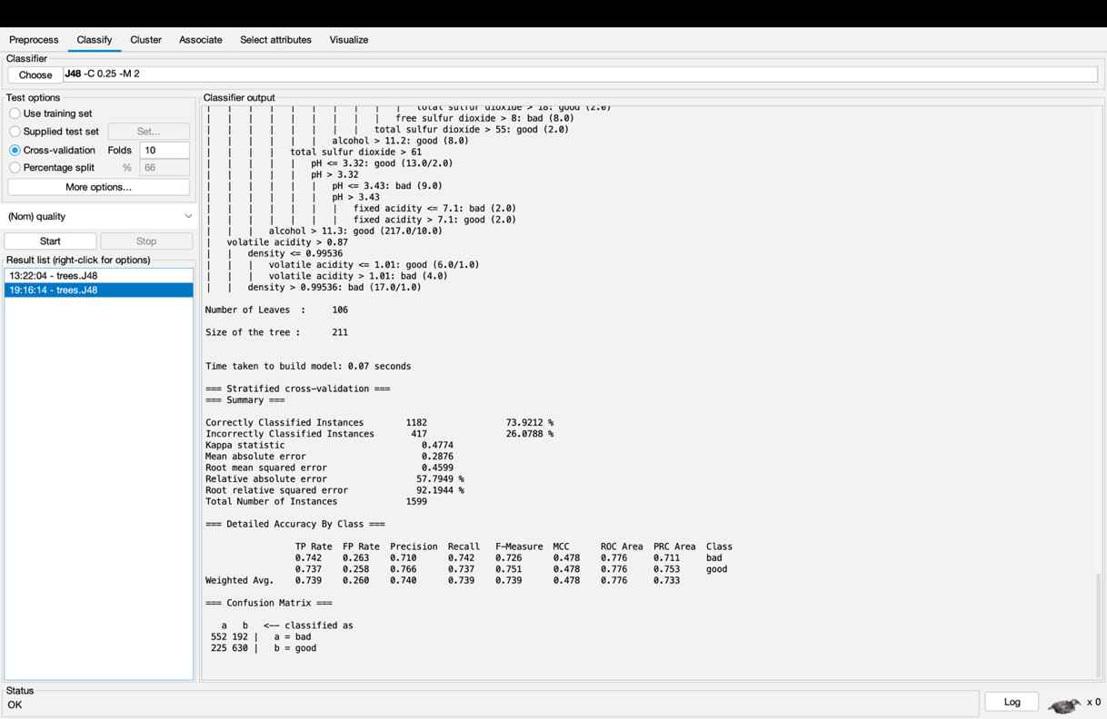

Decision Tree of J48 Algorithm on 10 folds of Cross-validation

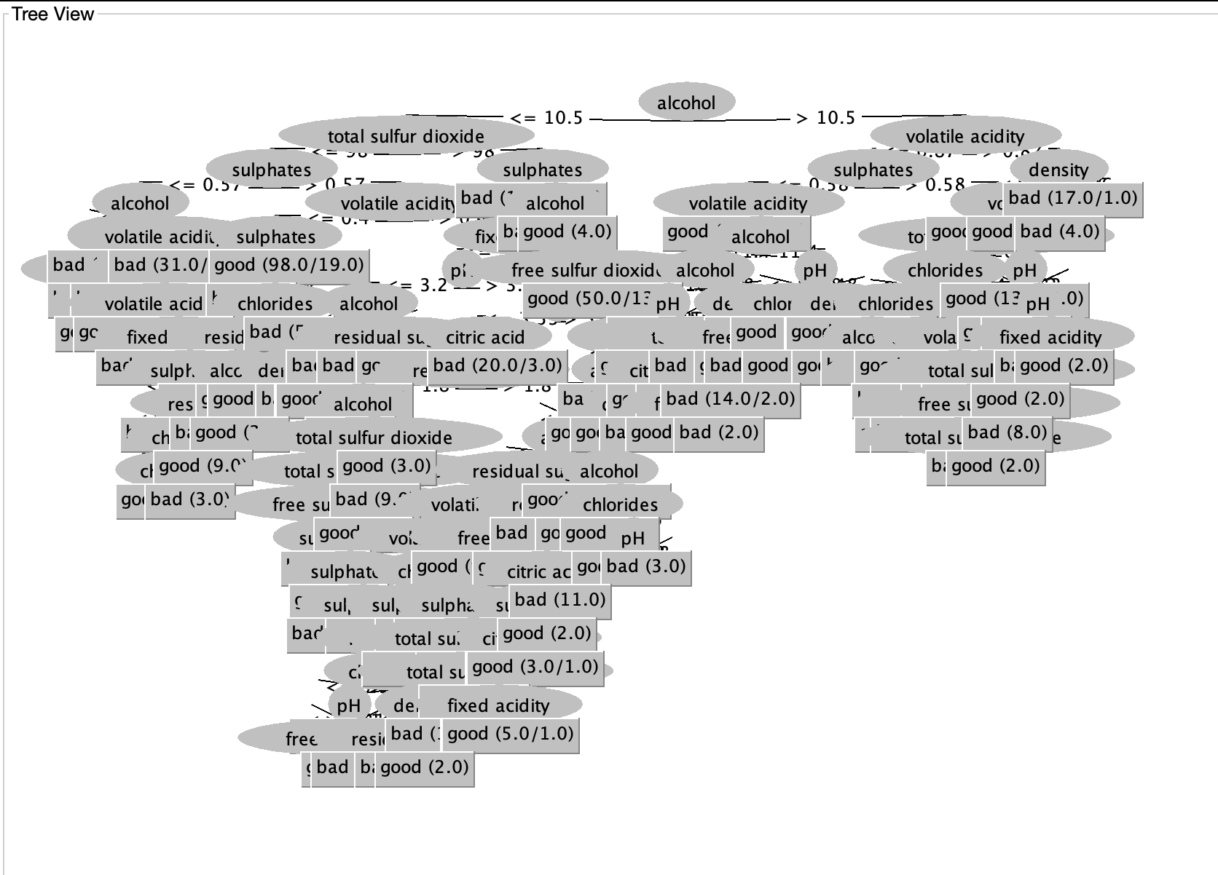

**Question #4: [10 marks]**

What is 10-fold cross-validation? What is the *main* reason for the difference between the percentage of Correctly Classified Instances when you used the entire training set directly versus when you ran 10-fold cross-validation on the training set? Why is cross-validation important?

Cross-validation is a test option in classifying a set of data with different algorithms to be able to predict the future or an outcome. Cross-validation is a commonly used option in classifying a data set. Its function is to divide the data set into parts or sets into the same number of folds. The algorithm will then run one part after another and gives out the percentage of the accuracy until all the parts are run once, then the average of the percentage of the parts will be give out. That average will the accuracy we can see in the result.

The percentage of Correctly Classified instances when using the entire training set directly is based on the result after running the algorithm on all the data in the training set. This incident calculates the outcomes more accurately due to the fact that ups and downs and errors occur in the same sets or parts and everything can relate to one another. But when only 10-fold cross validation on the training set is used, the algorithm will have to put up to missing data or some kind of unrelated obstacle. This causes the percentage of Correctly Classified Instances to get lower. In some of the parts in 10-fold cross validation, there may be also high percentage of Correctly Classified Instance. This can be due to the accident fetching for all related and easily predictable data. But when it comes to average percent, displayed accuracy, it is quite low when compare to that of running algorithm on the entire training set.

There are many reasons why cross-validation is important. When the data is unseen or missing, the cross-validation provide a reliable evaluation. Some algorithms are known for overfitting when the data get huge. This testing-method, cross-validation limits the amount of the data from the data set and run algorithm on the limited data. This causes the problem of overfitting to decrease. Since the cross-validation divides the data into multiple folds, this method can help in comparing the model and will be able to select the best outcome.

Task 1 – Part 3: Build Your Own Classifier

The following algorithms are some of the algorithms I run to compare one another to find the best suitable for explanations. All the algorithms are run on a.arff with the test option of training set.

Naives Bayes Algorithm

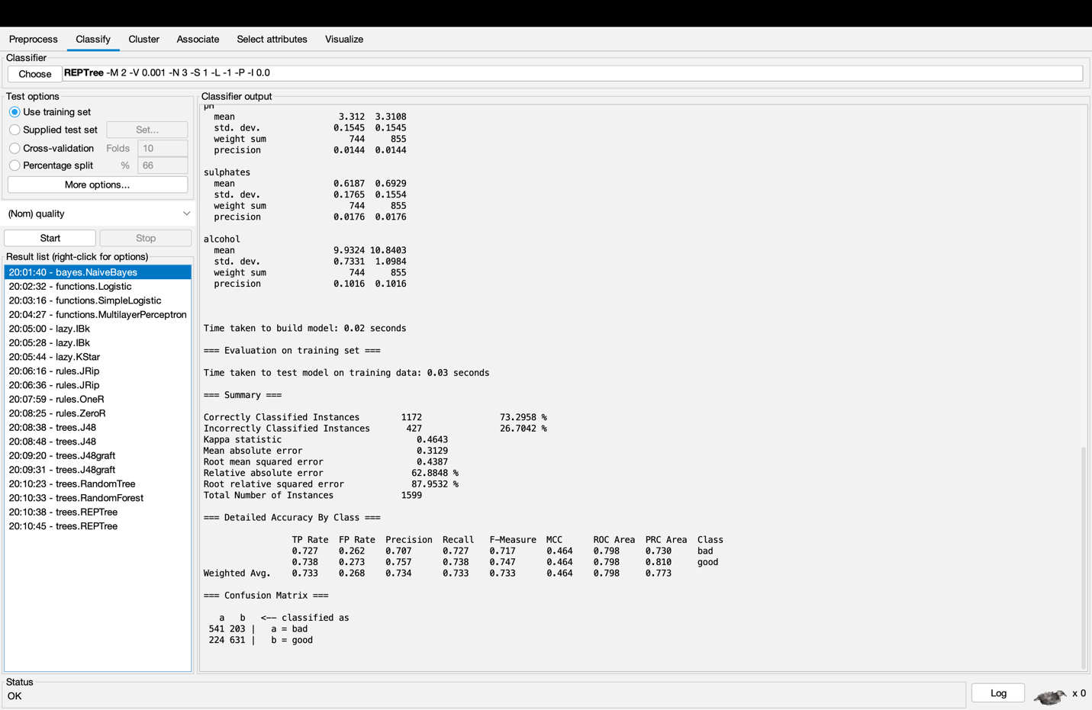

Logistic Algorithm

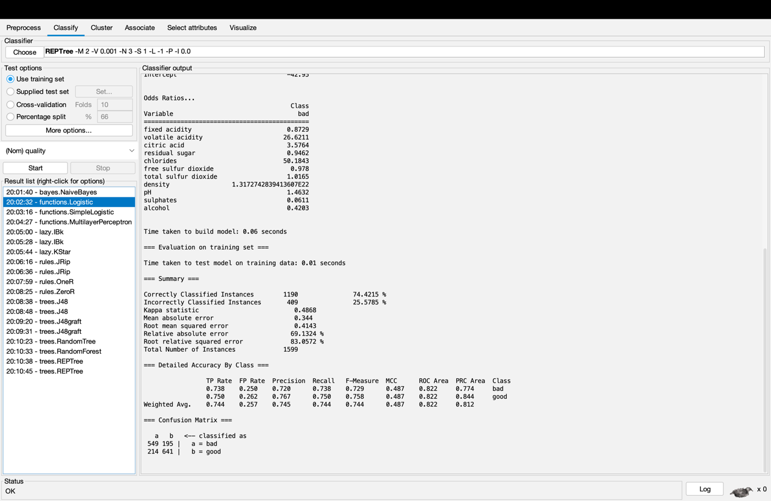

Simple Logistic Algorithm

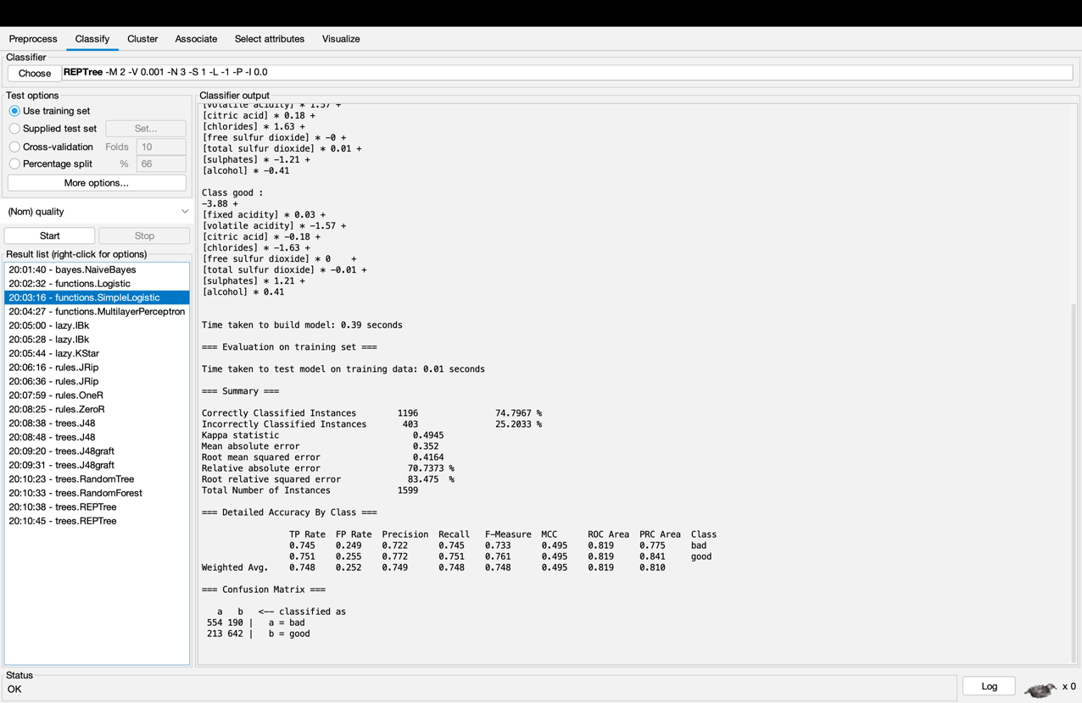

Multilayer Perception Algorithm

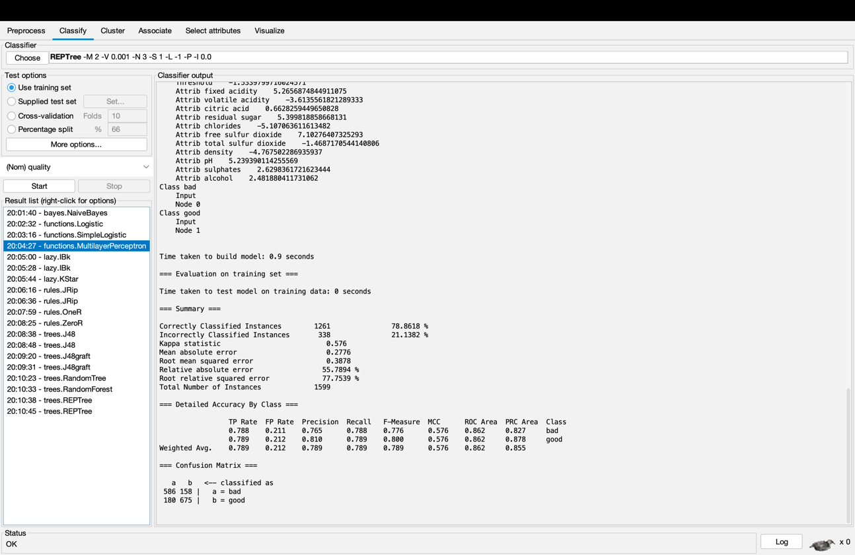

IBK Algorithm with distance function = Euclidean Distance

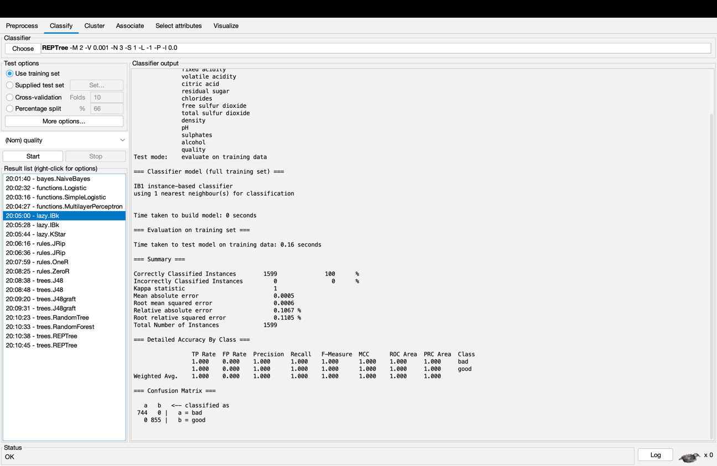

IBK Algorithm with distance function = Manhattan Distance

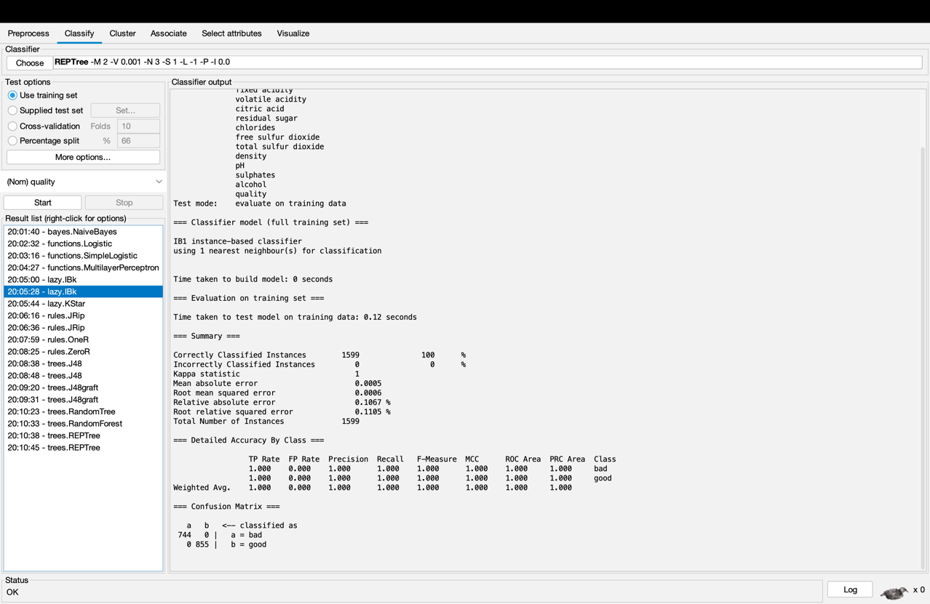

KStar Algorithm

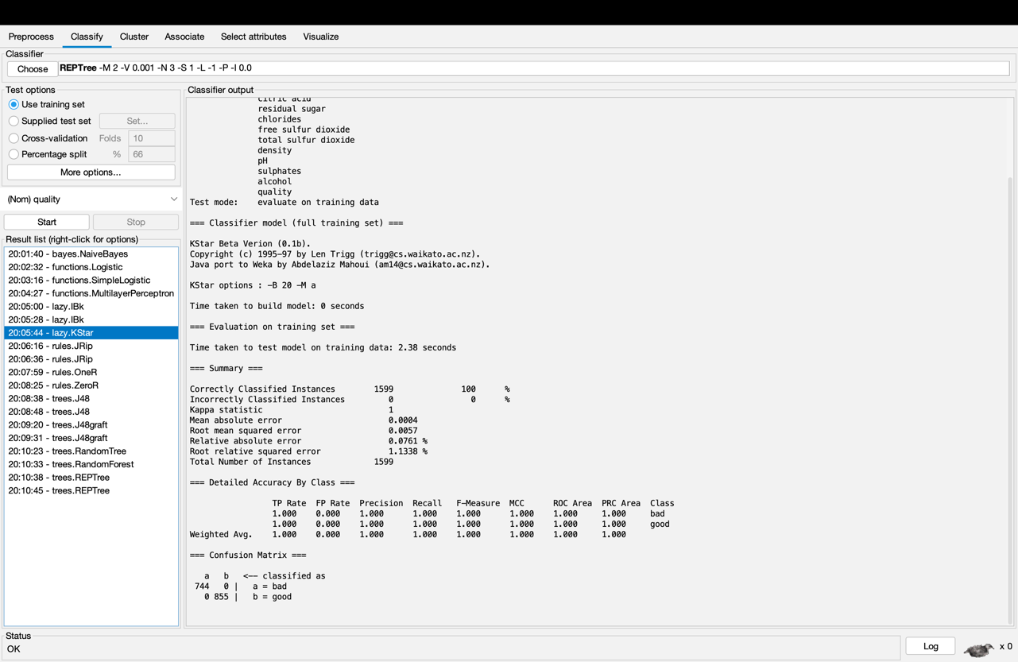

JRip Algorithm with use Pruning = True

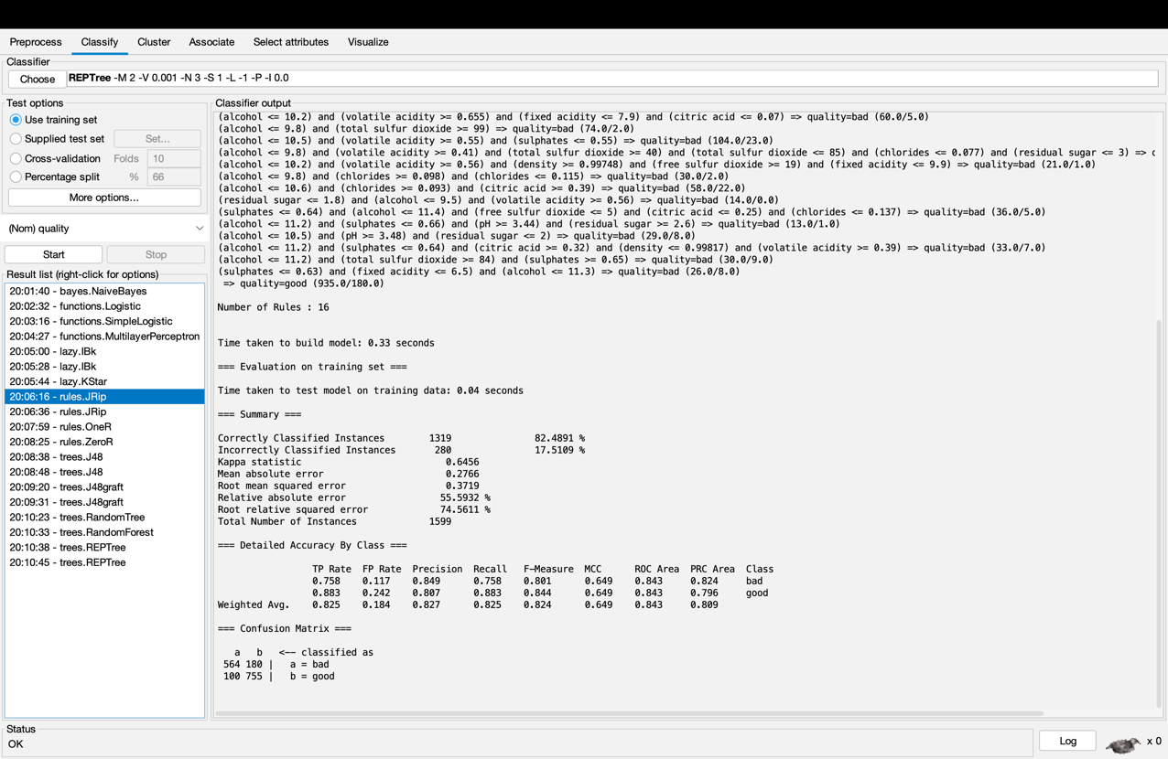

JRip Algorithm with use Pruning = False

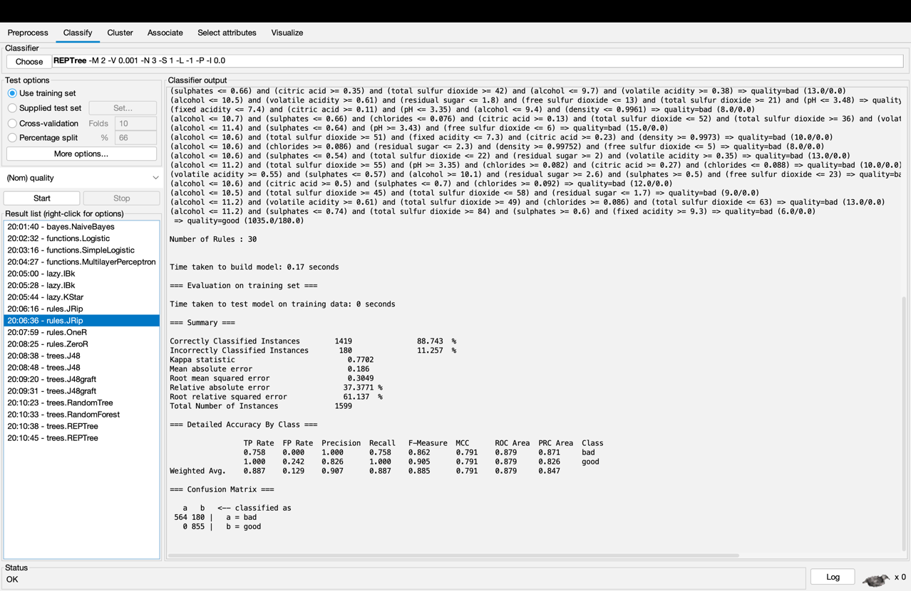

One R Algorithm

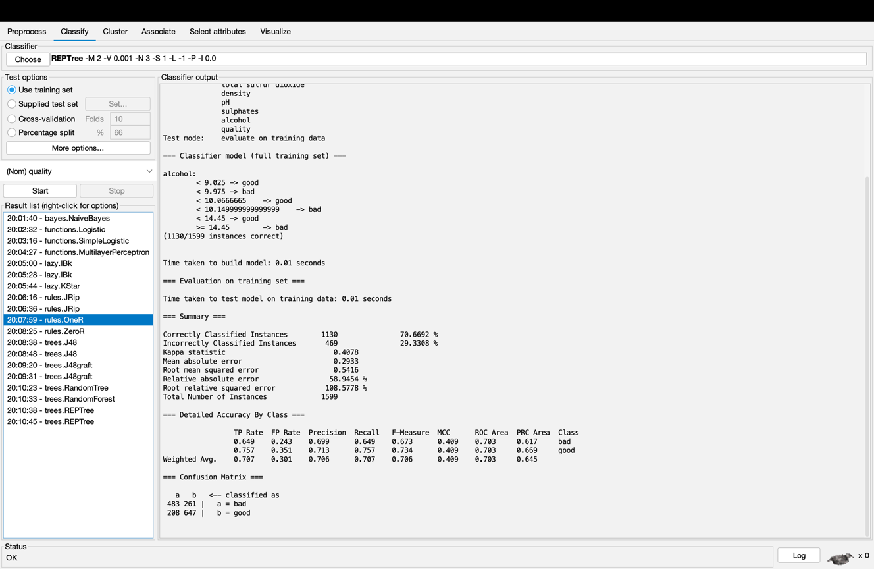

Zero R Alogrithm

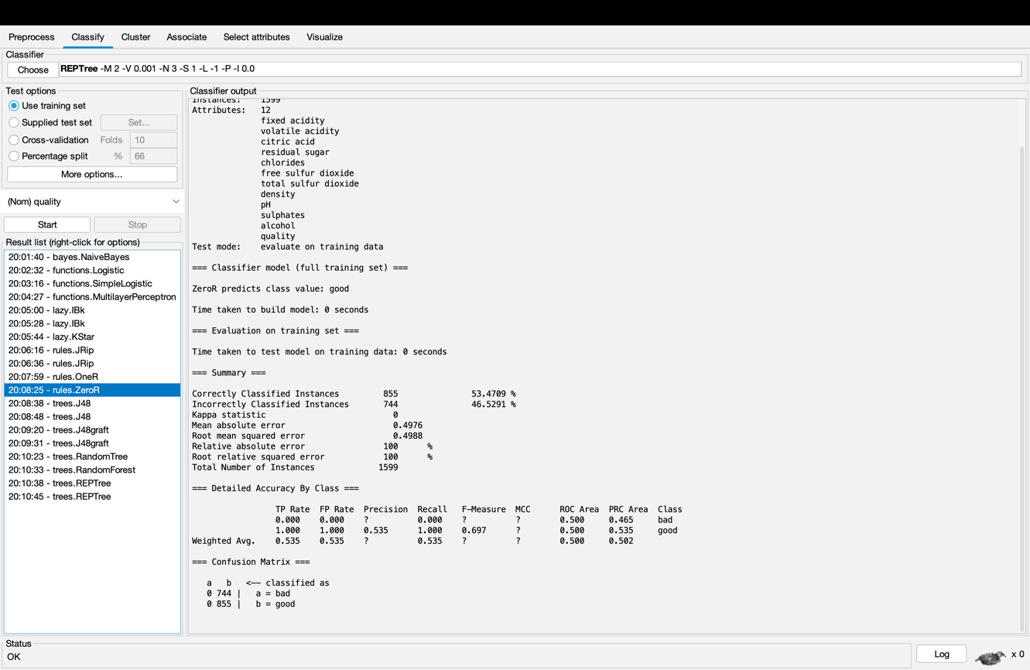

J48 Algorithm with Unpruned = False

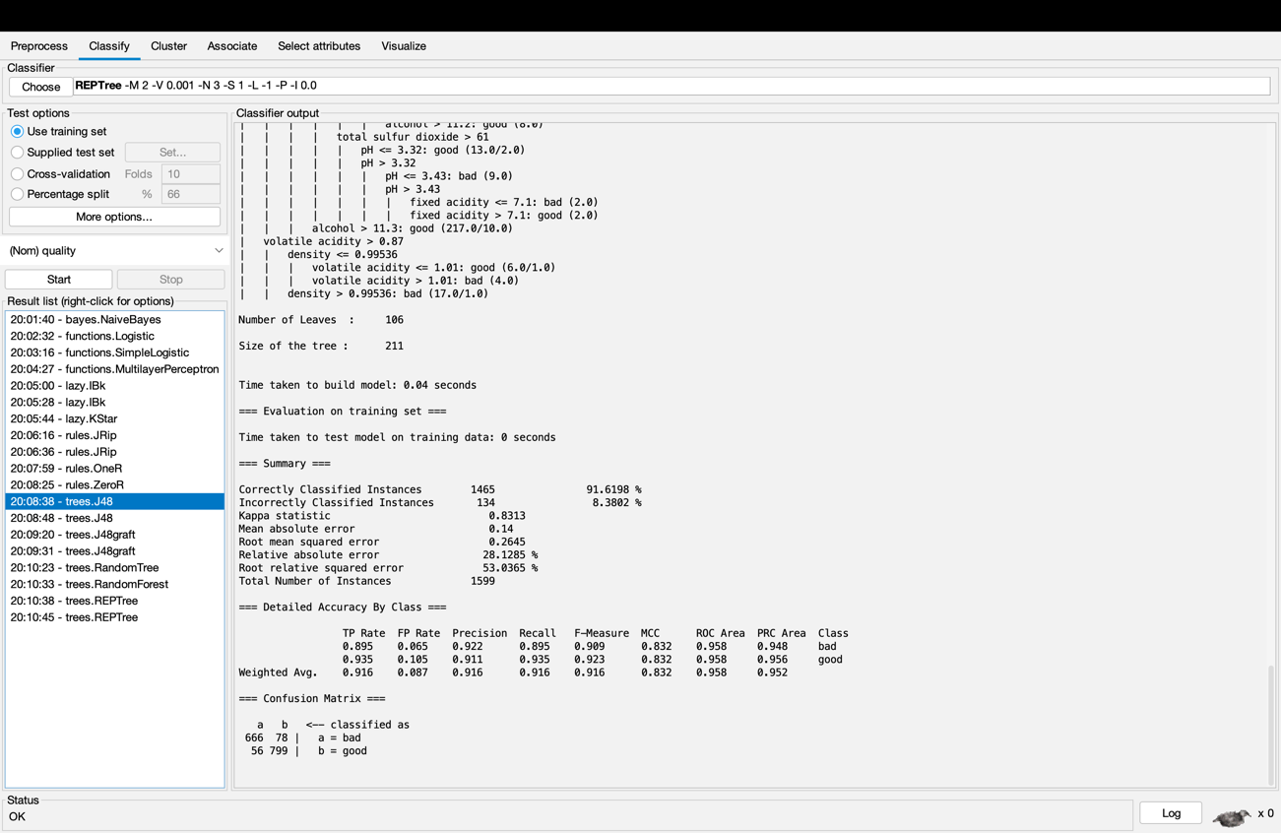

J48 Algorithm with Unpruned = True

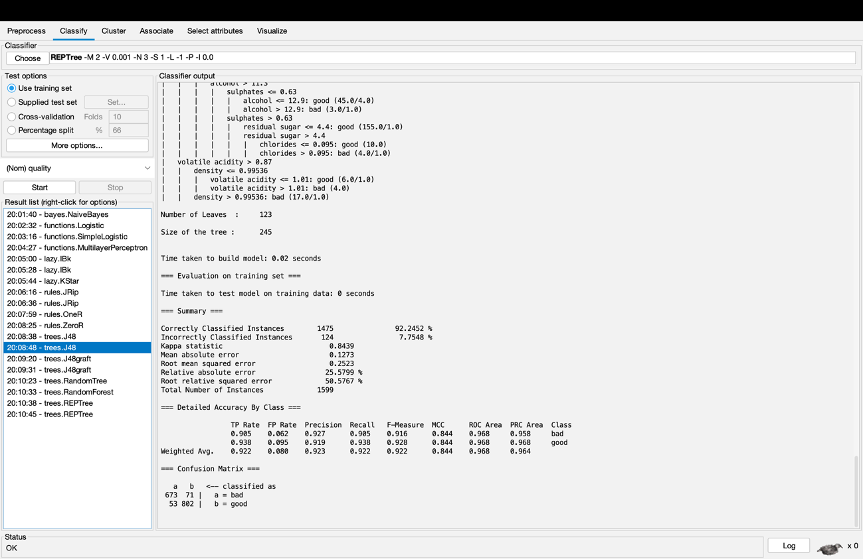

J48 graft Algorithm with Unpruned = False

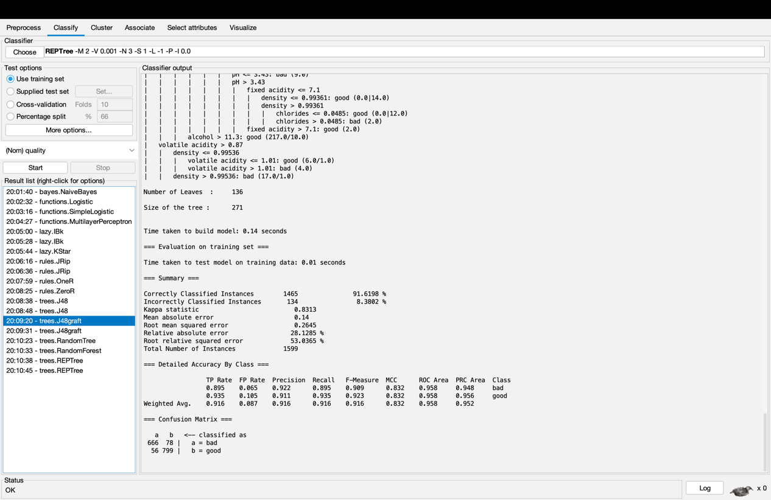

J48 graft Algorithm with Unpruned = True

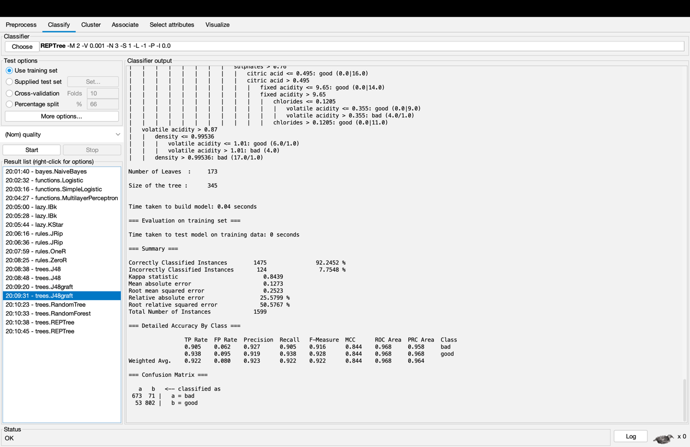

Random Tree Algorithm

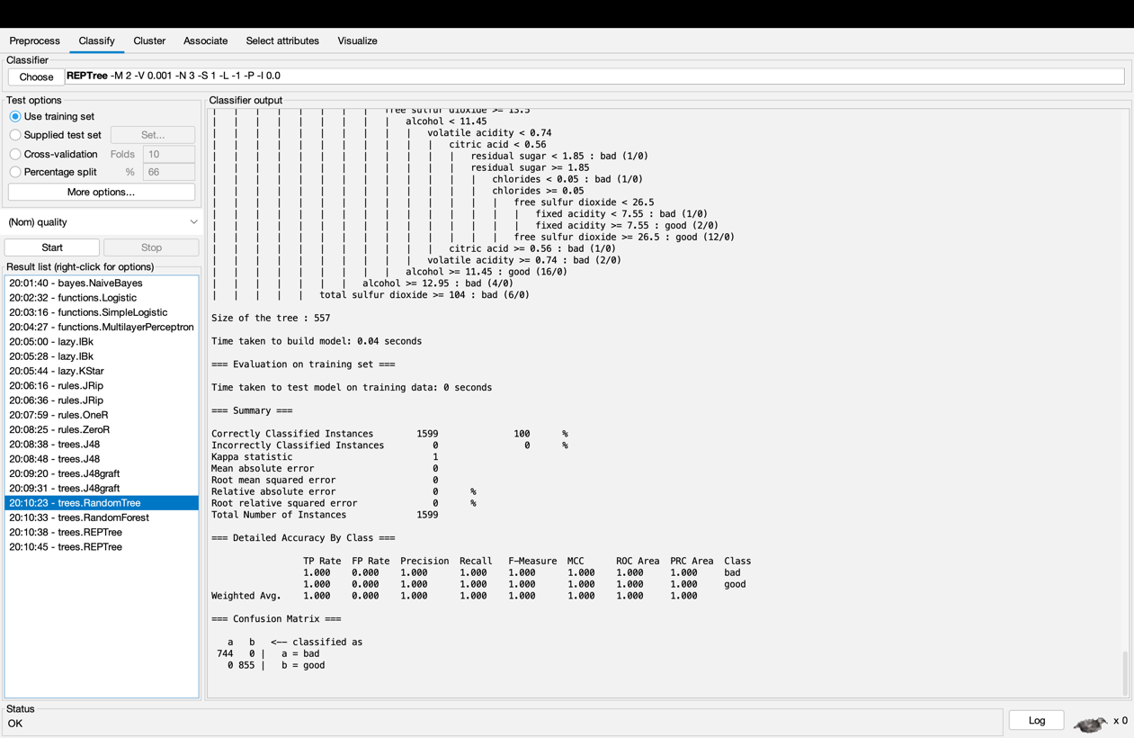

Random Forest Algorithm

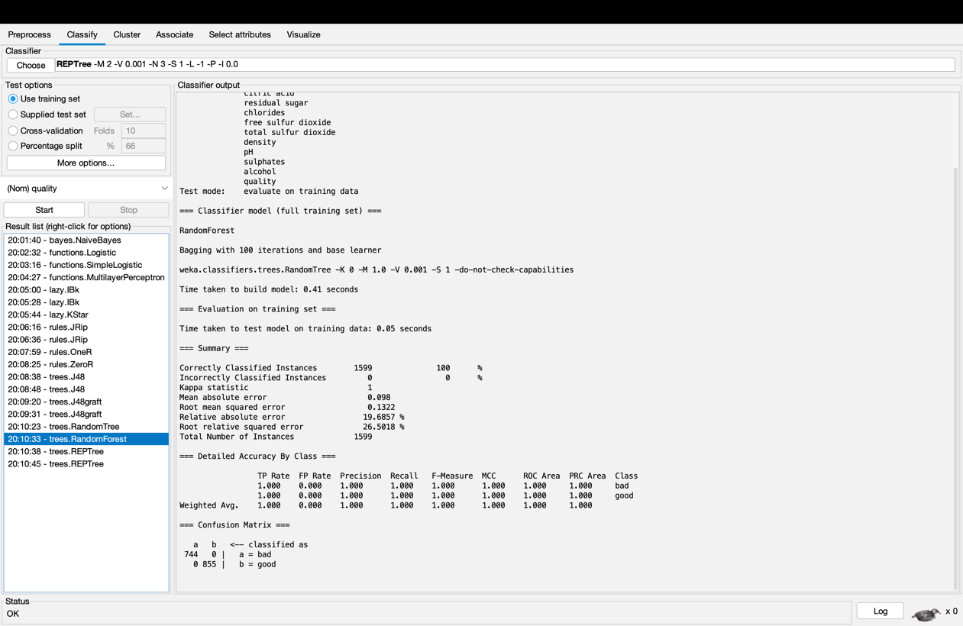

REPTree Algorithm with no Pruning = False

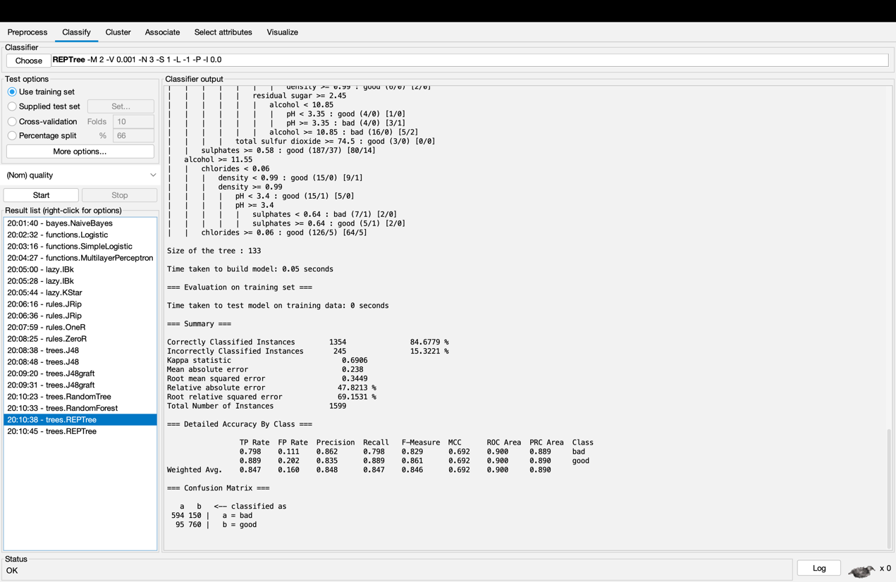

REPTree Algorithm with no Pruning = True

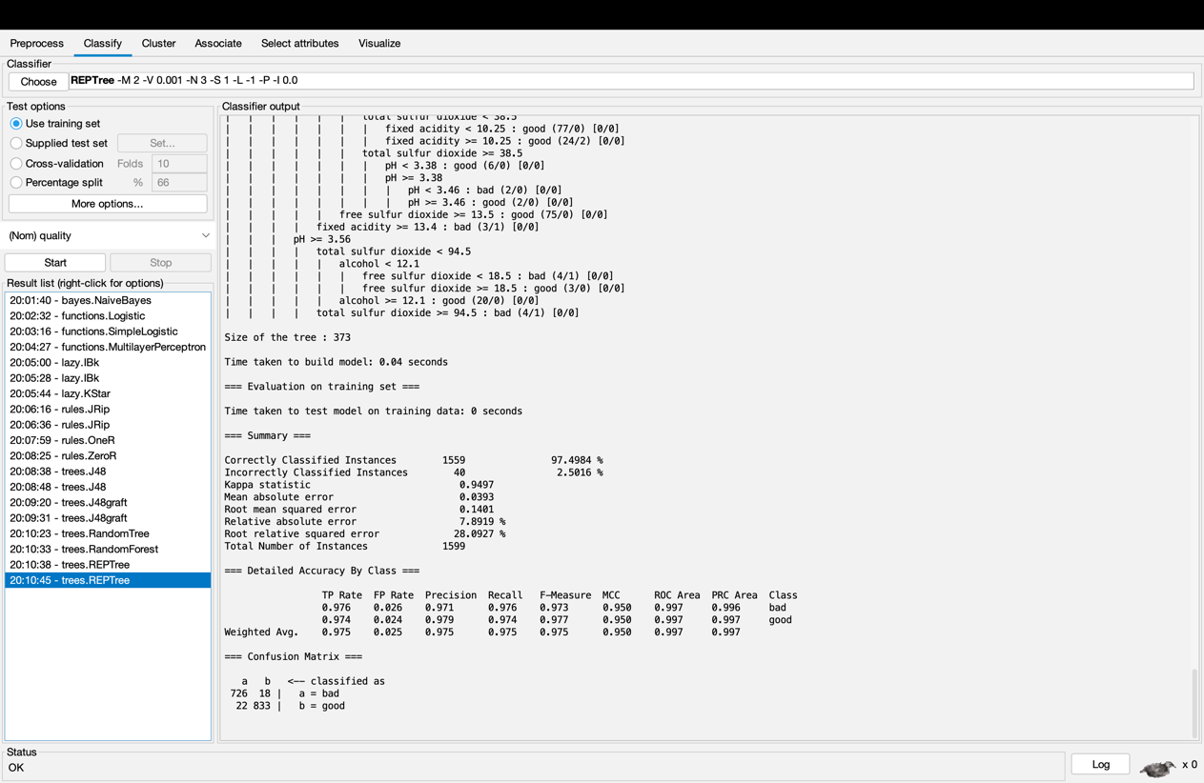

**Question #5: [5 marks]**

What is the "command-line" for the model you are submitting? For example, *"J48 -C 0.25 -M 2"*. What is the reported accuracy for your model using 10-fold cross-validation?

REPTree – M 2 -V 0.001 -N 3 -S 1 -L -1 -P -1 0.0 is the “command-line” for the model I will be submitting.

Here is the result of the reported accuracy for my model using 10-fold cross-validation.

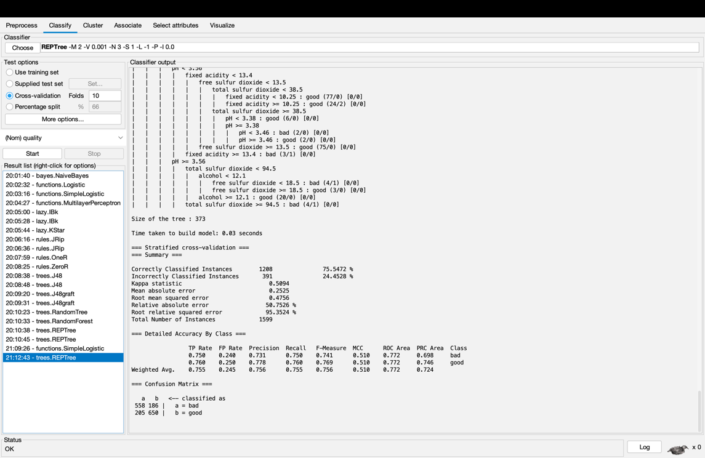

Here is the REP tree algorithm running the training set

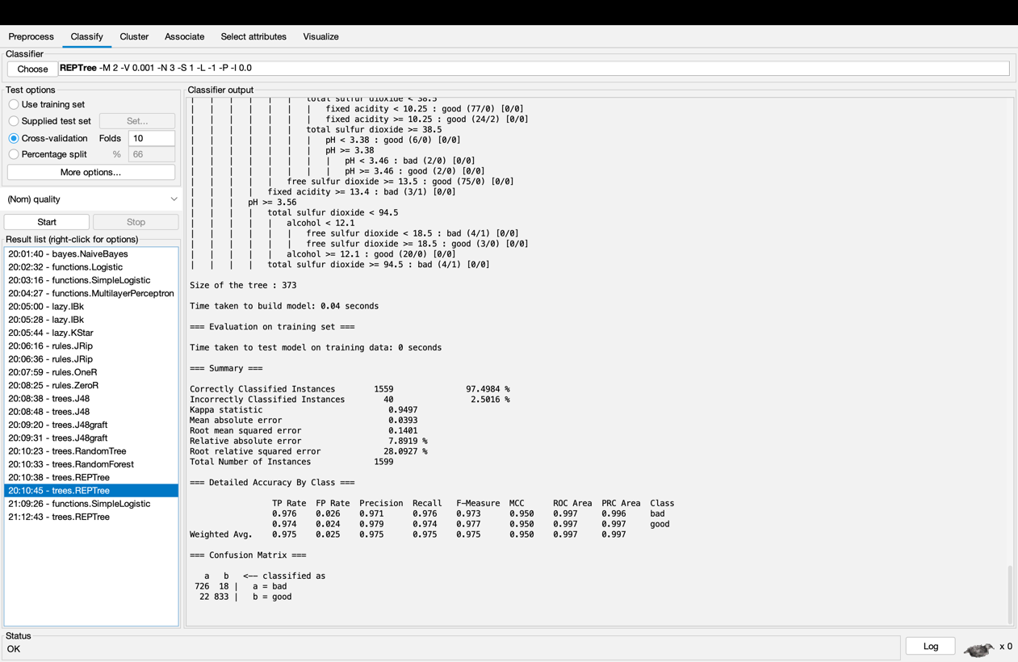

Here is the REP Tree algorithm running with the percentage split of 66 percent

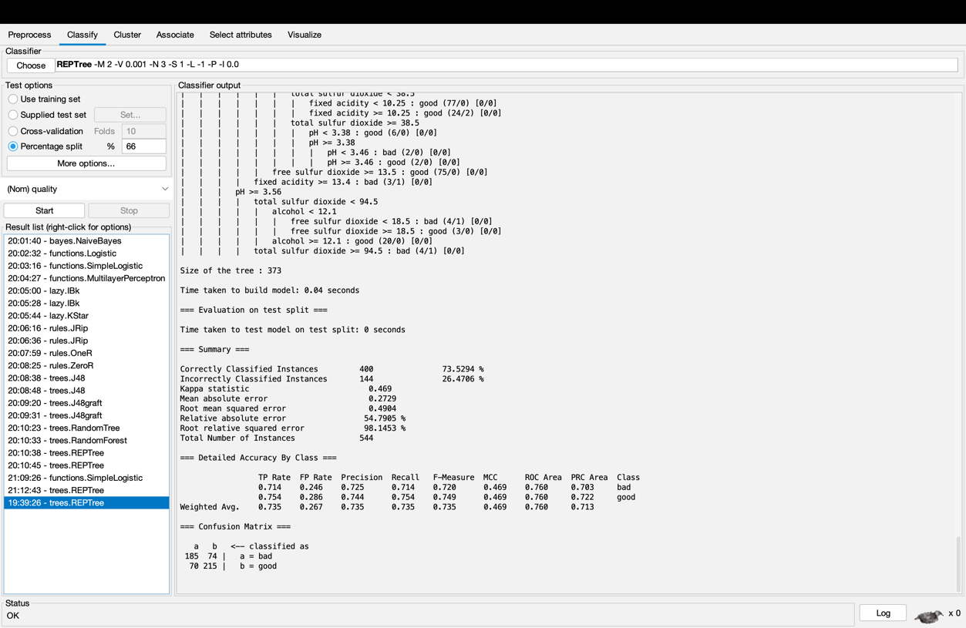

**Question #6: [20 marks]**

In a few sentences, describe how you chose the model you are submitting. Be sure to mention your validation strategy and whether you tried varying any of the model parameters.

I chose this model due to the clear and intuitive decision rules. It can be easily understood and explained by a human. The REPTree algorithm is really good at handling large datasets and performs well on missing datasets. It has a really good result when running with training dataset. The accuracy shifts pretty low when the data set is divided into folds. The accuracy gets worst when trying out with the percentage of the total data.

When trying out with training dataset, the accuracy rate is pretty promising with only a little error on it. I believe by using this data, we can be able to predict the farther outcomes and react to it before even knowing the real result.

But when trying out 10-fold-validation, the accuracy drops. This can be due to the missing data gets worse and limited data to work on. Therefore, when the average accuracy of the model is displayed, it is quite low when comparing with model running on training dataset.

The worst accuracy is seen in the model when trying to run with the percentage split. Normally when running with percentage split there are only a small number of changes when even comparing with running on training set.

Therefore, I choose to use the model of the test option of training set running with REP Tree Algorithm.

REPTREE Algorithm running on training dataset (no Pruning = FALSE)

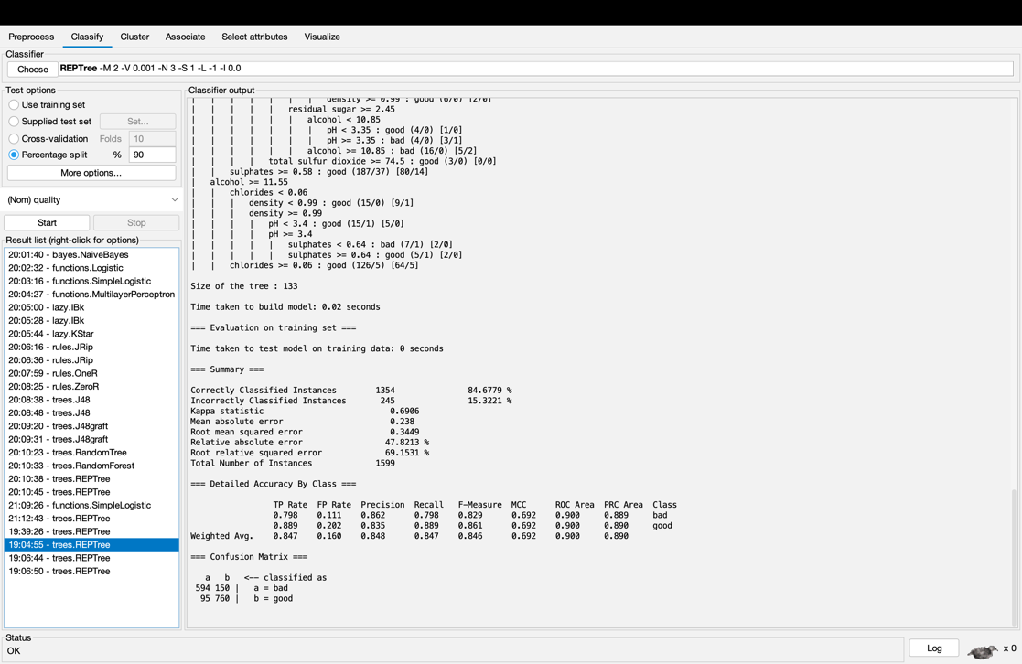

REPTREE Algorithm running on Cross-validation of 10 folds (no Pruning = FALSE)

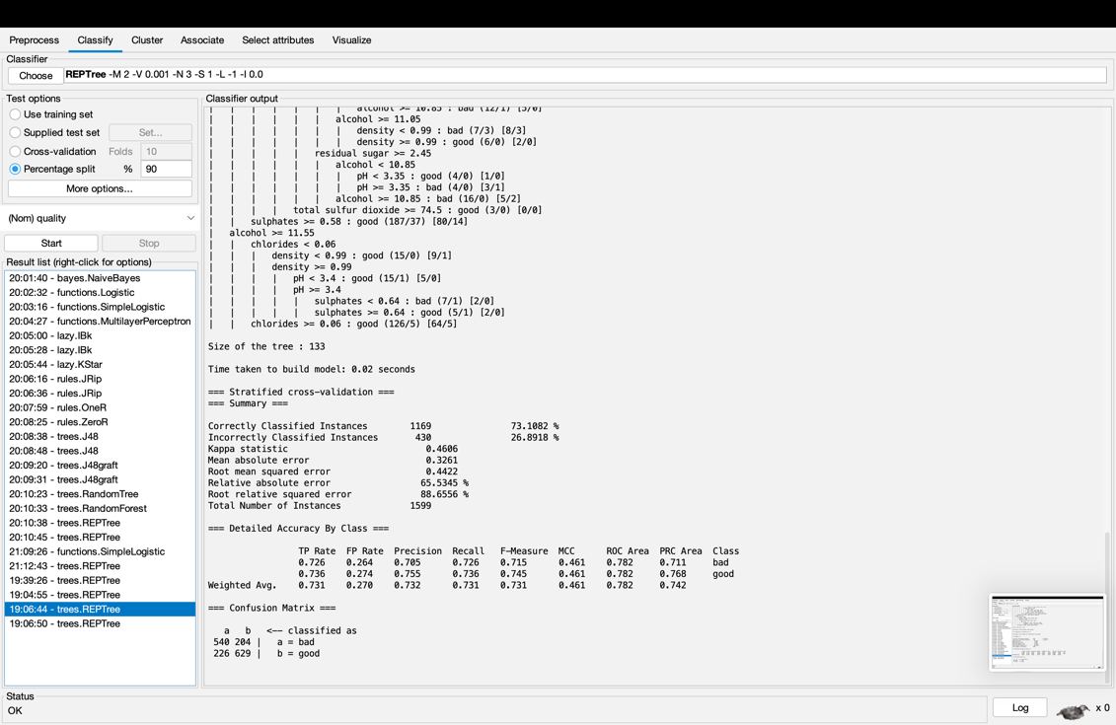

REPTREE Algorithm running on Percentage split of 66 percentage (no Pruning = FALSE)

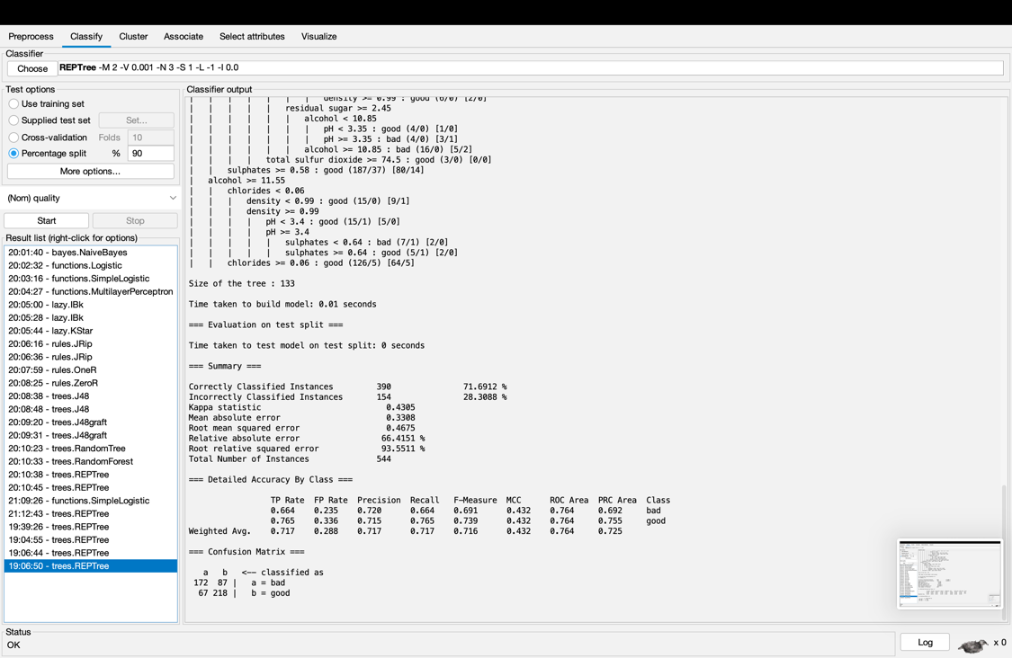

**Question #7: [15 marks]**

For your selected classifier model, investigate what kind of parameters are available to be set in Weka and briefly summarise of the role of each parameter.

Throughout the various configuration testing, summarise your findings about the effect (on the result of testing the model using test data) of three different parameters of your choice.

Parameters of REPTree Algorithm

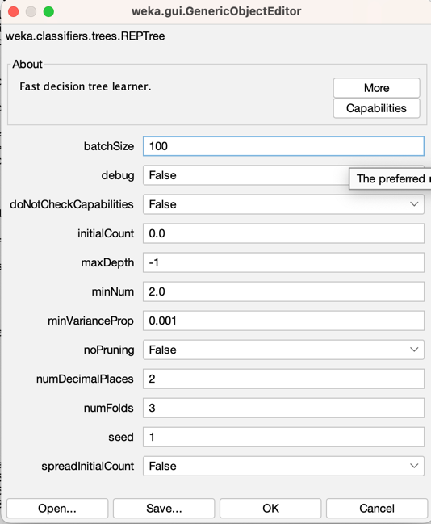

In the REPTree Algorithm, the batch size can be changed which means the number of samples or instances used to update the model.

The debug function can be modified as either False or True. The debug function identifies and resolves issues and errors which takes place when the algorithm is being run and the model is created.

The doNotCheckCapabilites function can also be selected as either True or False. This function decides whether to disable the capability checking during model building or not.

The initial count can be changed. This function does not have a specific function but it determines how much initial can be associated in the data.

The max Depth can be changed but it can both in positive or negative form. This function determines the limit of depth of the decision tree.

The minNum can be changed but it can only be in positive form. This function determines the minimum of instances needed to make a new split when creating the decision tree.

The minVarianceProp can be changed but only in a decimal form. This function determines the minimum proportion of variance allowed for creating a new split.

The no Pruning function can be chosen as either True or False. This function is to reduce the complexity of the decision by removing the training data which are overfitting.

The numDecimalPlaces can be changes. This determines the decimal place in the percentage of the model after running the algorithm.

The numFolds can be changed based on the data being put into. The result of the algorithm can be changed by this function. This function limits the amount of data into the number of folds then used in running the algorithm.

The seed function can be changed and it is also based on the data being put into. The function allows us to determine the starting point of the generation of random number.

The spreadintialCount function can be switch to True and False. This function determines the range of the function of initial Count.

I change the number of folds from 3 to 5. We can see the difference in the outcome of the model.

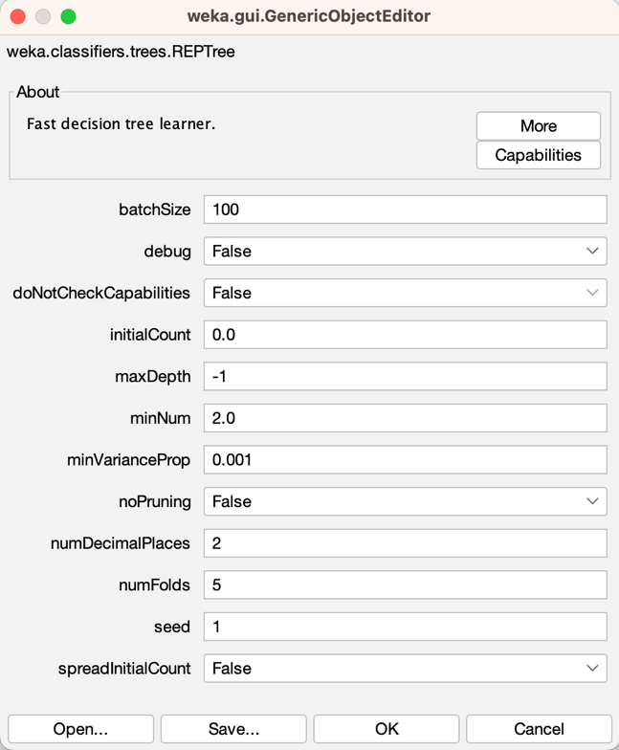

Before changing the number of folds

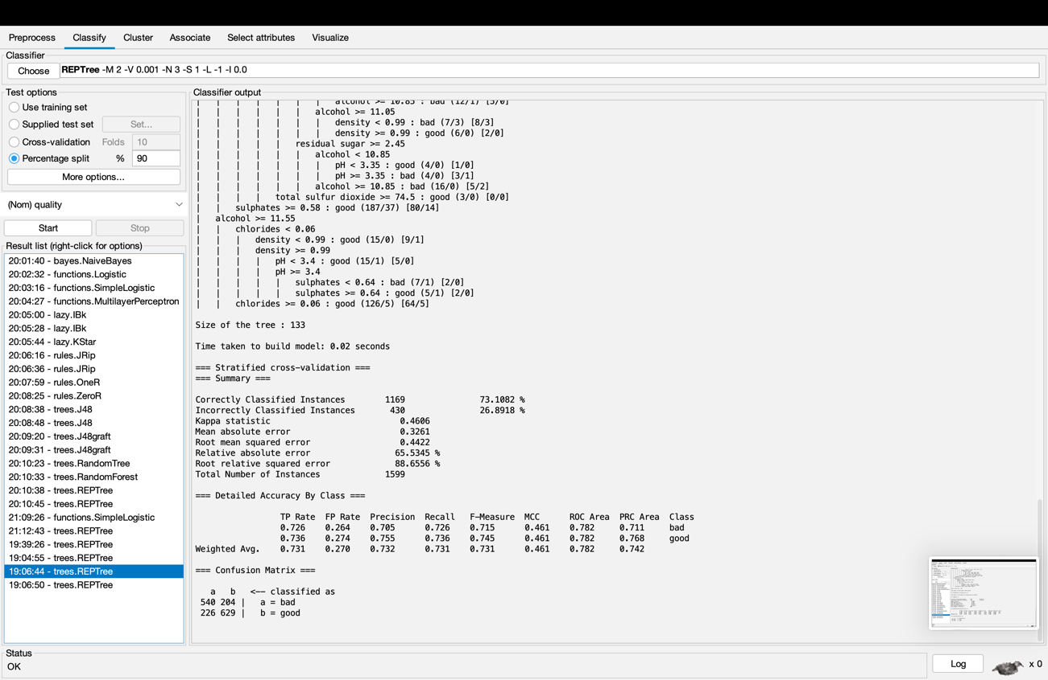

After changing the number of folds

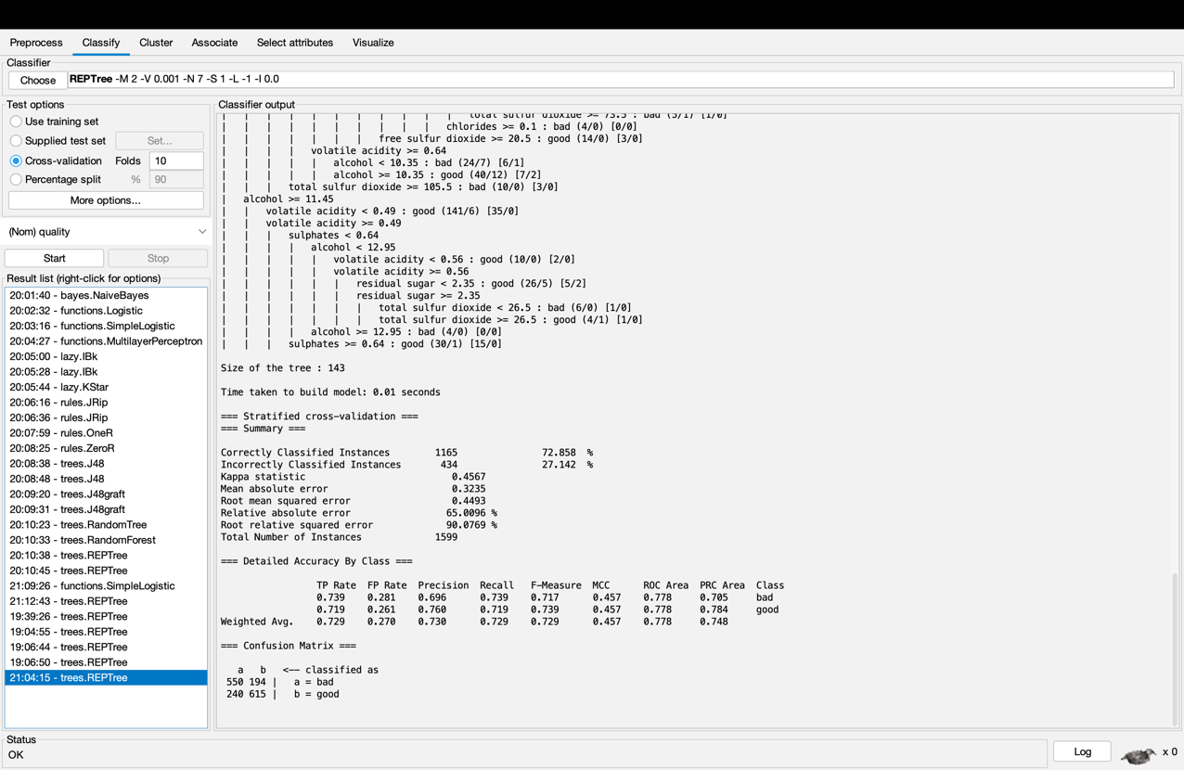

I change the num decimal places from 2 to 5. There is no difference in outcomes. The decimal place of the outcomes shift.

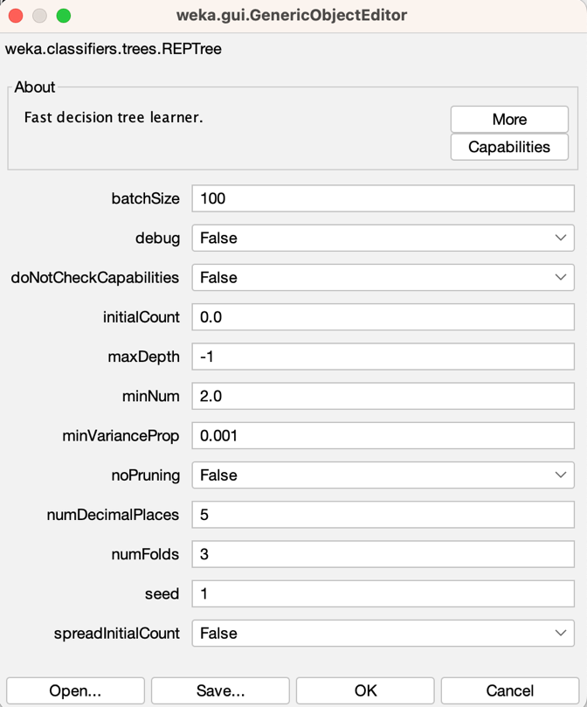

Before changing the num Decimal Places.

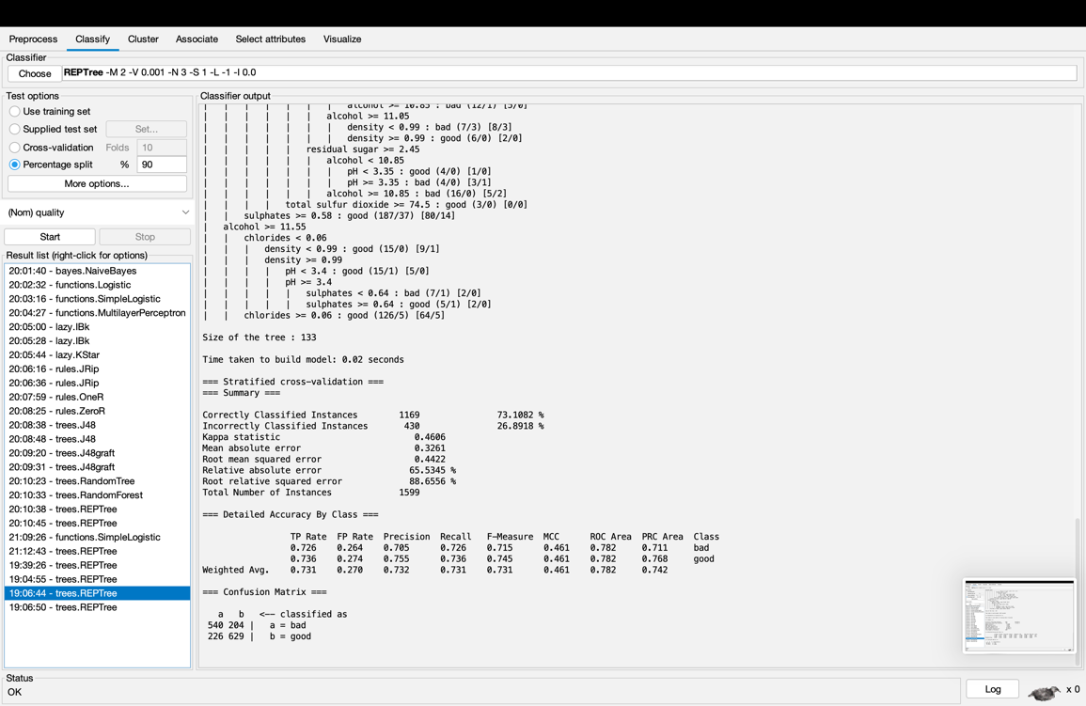

After changing num Decimal Places.

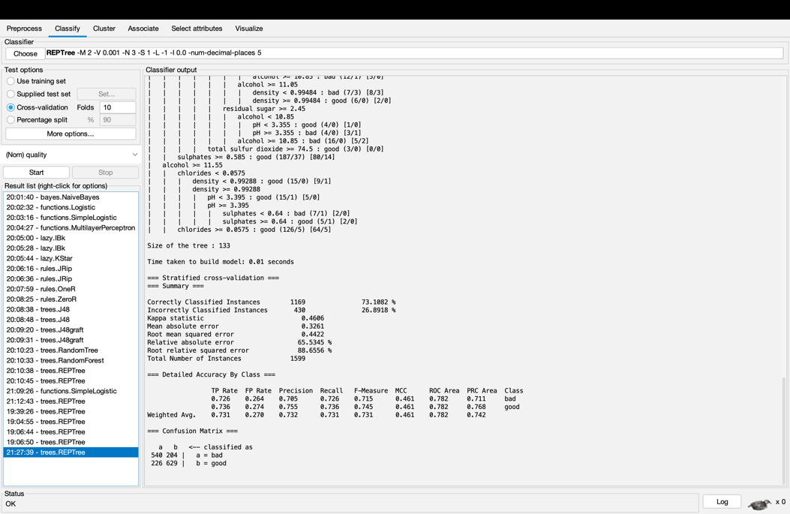

I change the mim Num from 2.0 to 3.0. There is a slight change in the percentage of the outcomes.

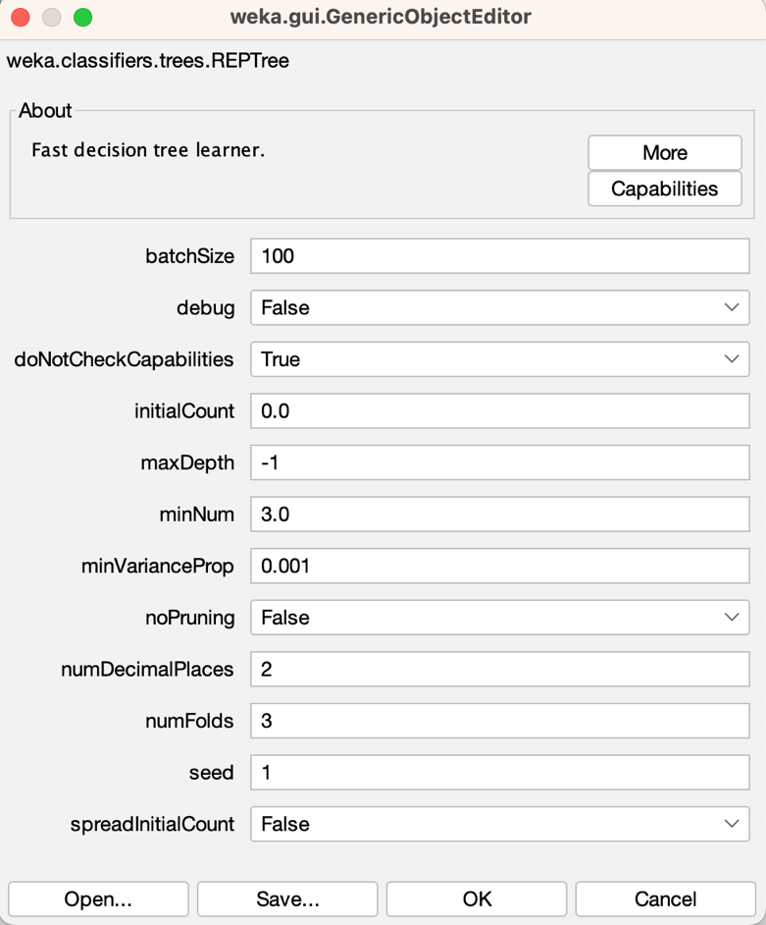

Before changing the min Num.

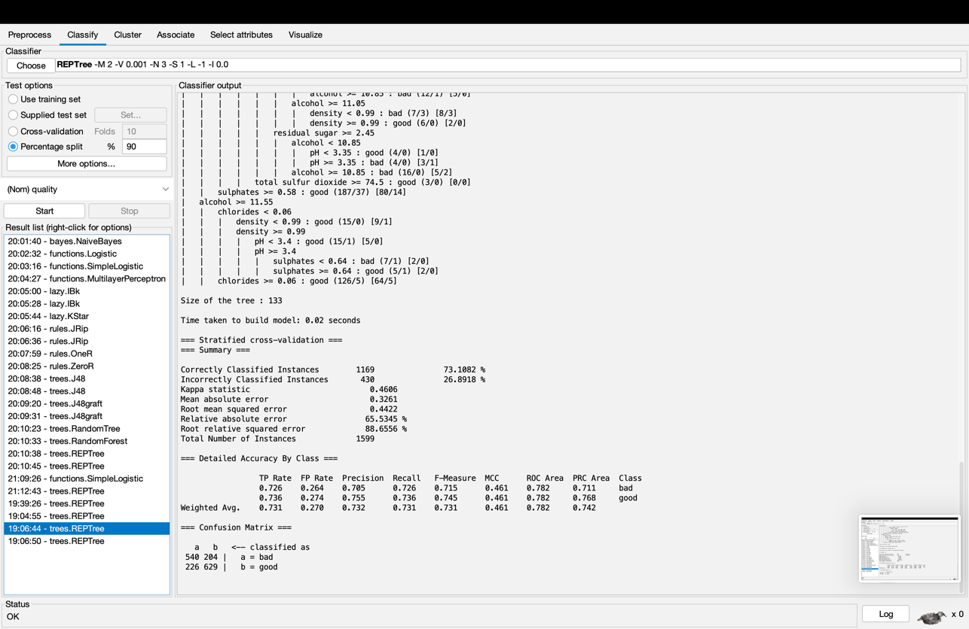

After changing the min Num.

